Exercises day 4-5-6-7-8 Maltie Parsoe

# A. Software part

1. Make yourself familiar with mqtt, mosquitto, mosquitto_pub, mosquitto_sub, and Node-RED (start mosquitto with iot and then mqtt_broker)

* Sending and receiving messages via mosquitto between at least two participants on at least two different devices
* Create cases to use and test wildcards (+ and #) and show them in action

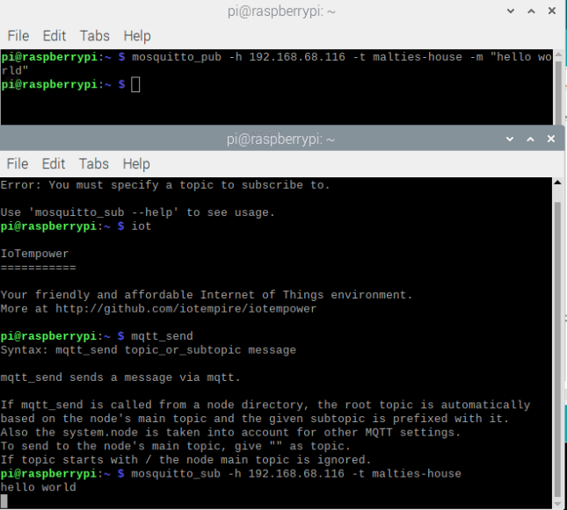

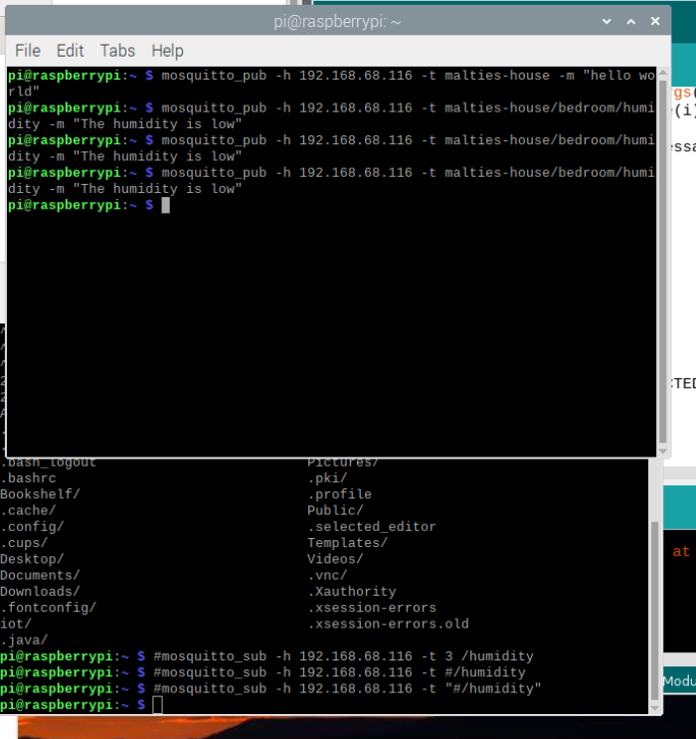

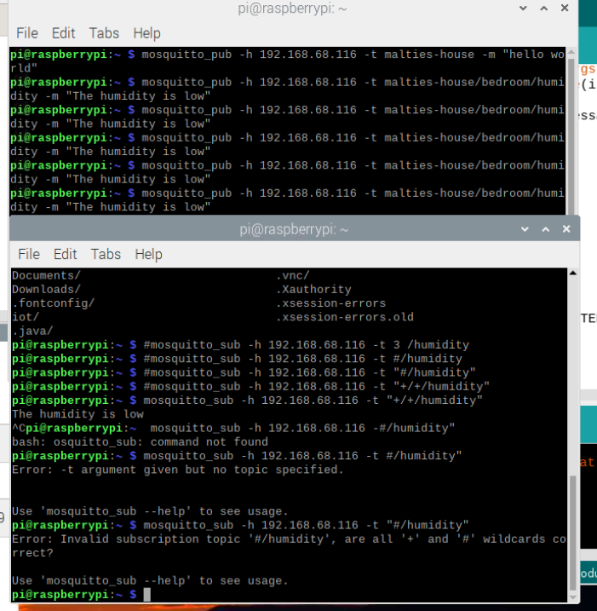 In the pictures above you can see that I am making myself familiar with mosquitto. I am also trying out different combinations of commands to see which will work.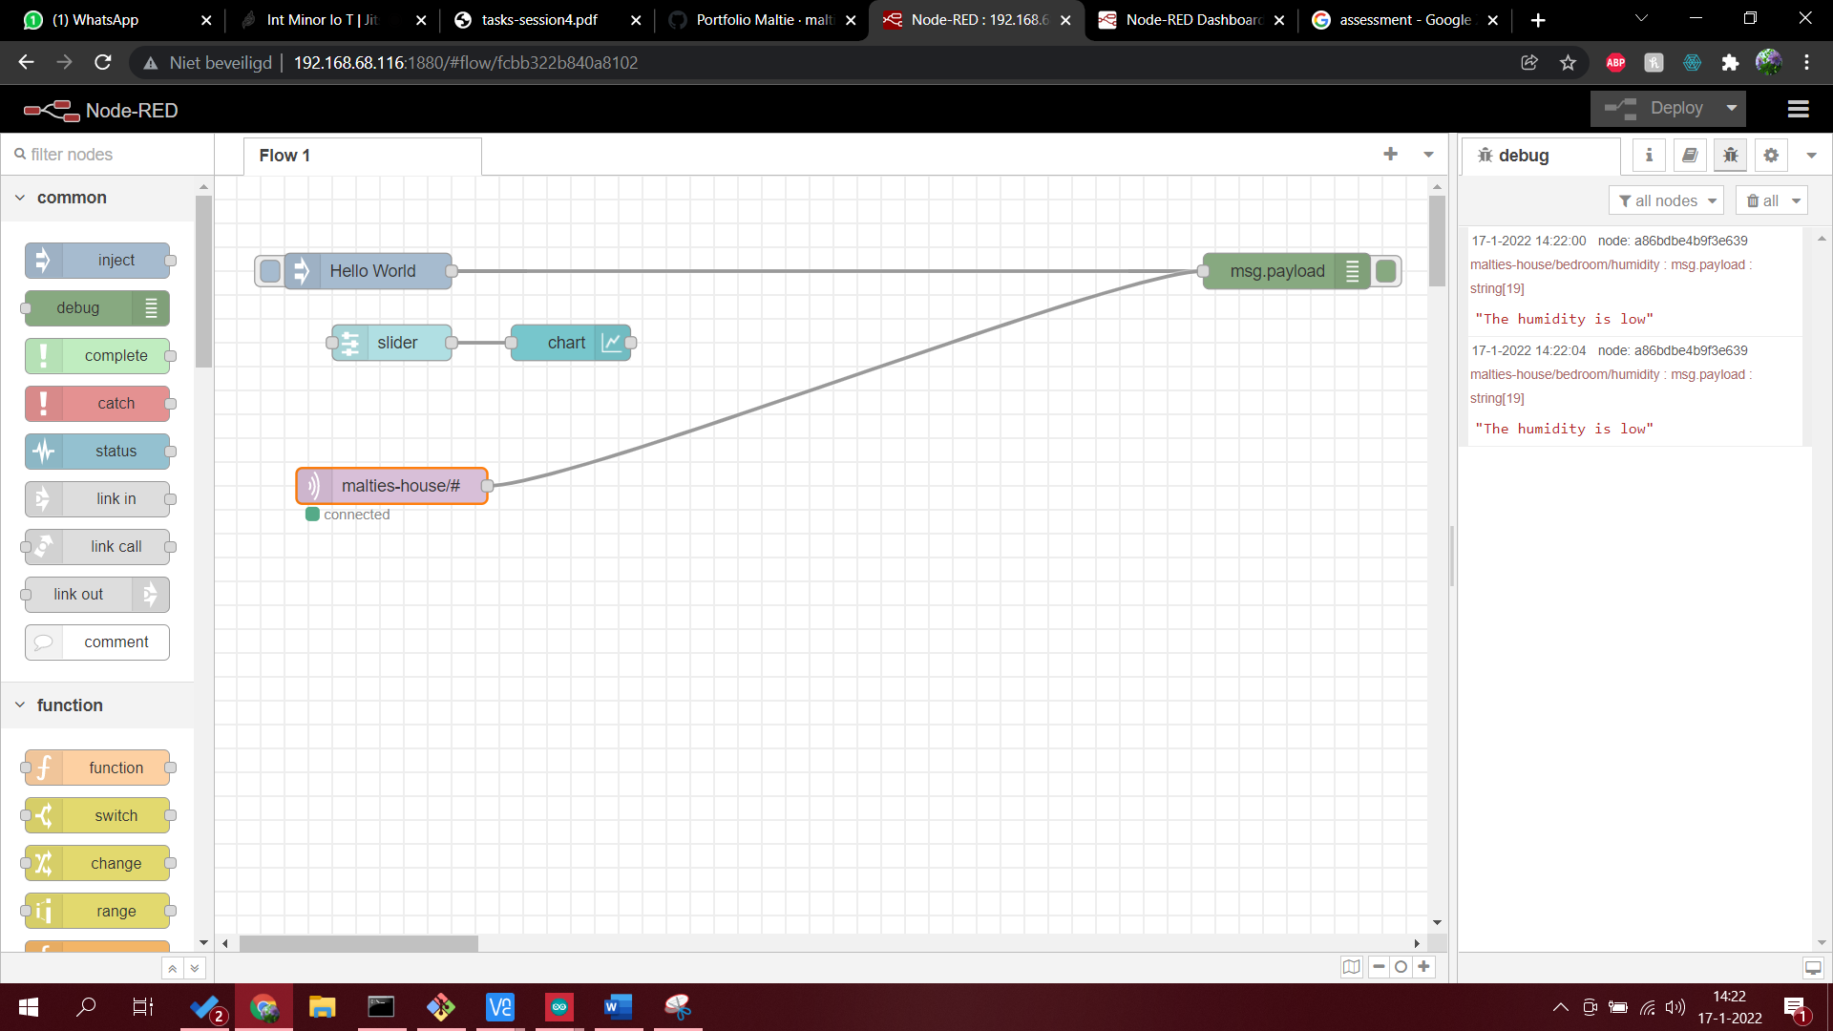

In the picture above I construct a flow in node-red where the mqtt publish should also be seen.

2. Build two simulators having cli or gui (use your preferred language and respective mqtt library, can use node-red)

* Sensor simulator: Temperature sensor simulator 1. Input start temp, end temp, time to linearly rise → then run this simulation

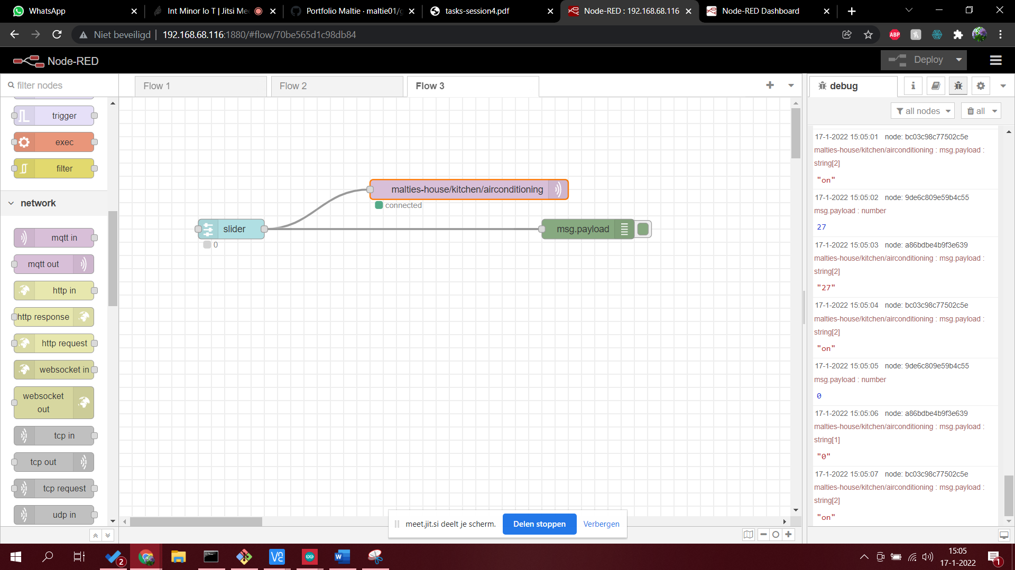

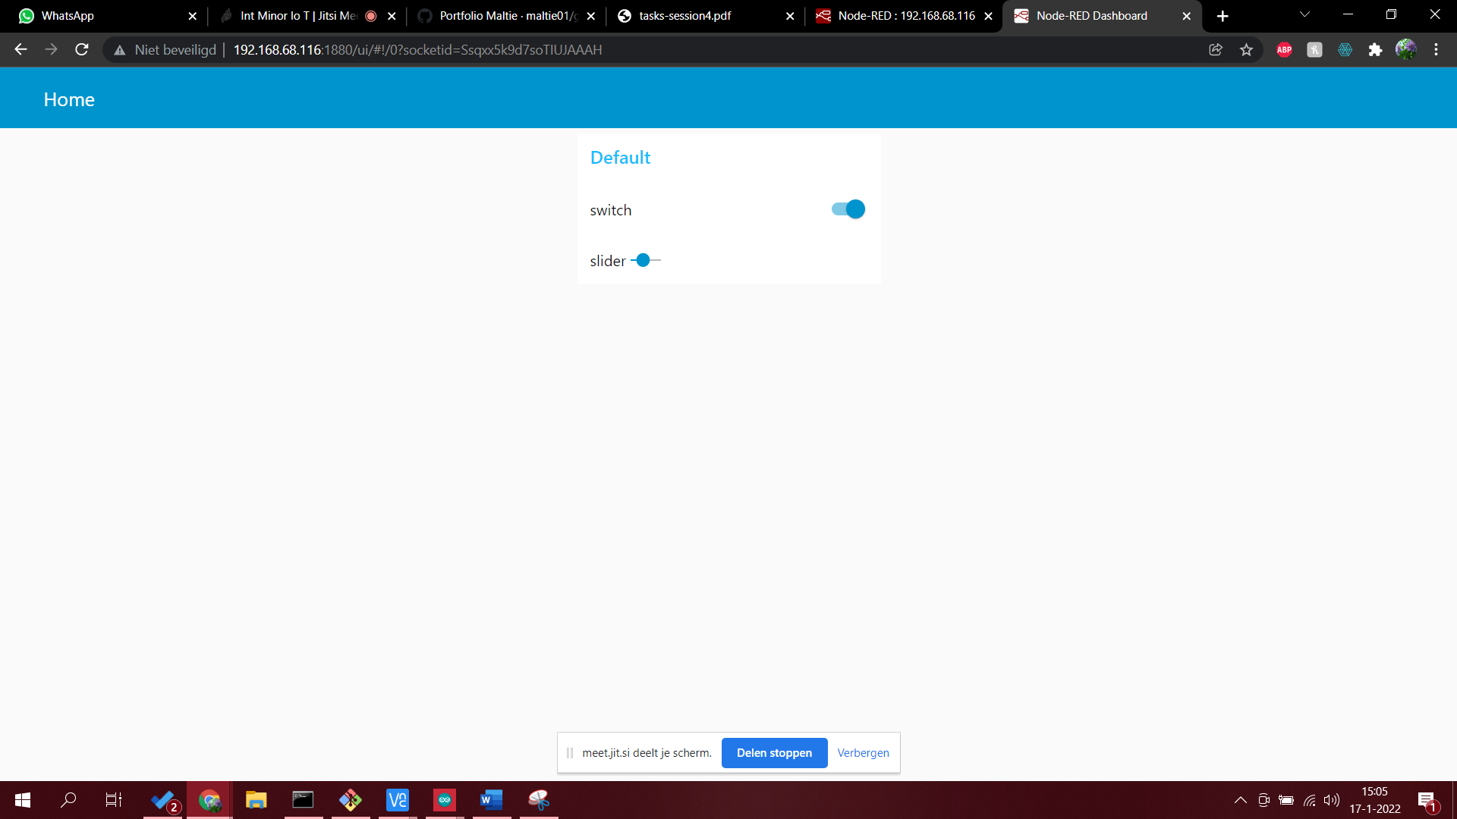

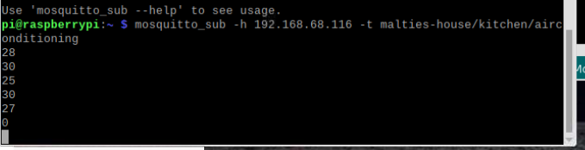

In the pictures above I show that I can make a temperature sensor simulator and that this data is been sent by mosquitto to the console.

* Relay simulator: Relay switch (like AC) simulator 1. Showing on and off → can be switched to these states remotely

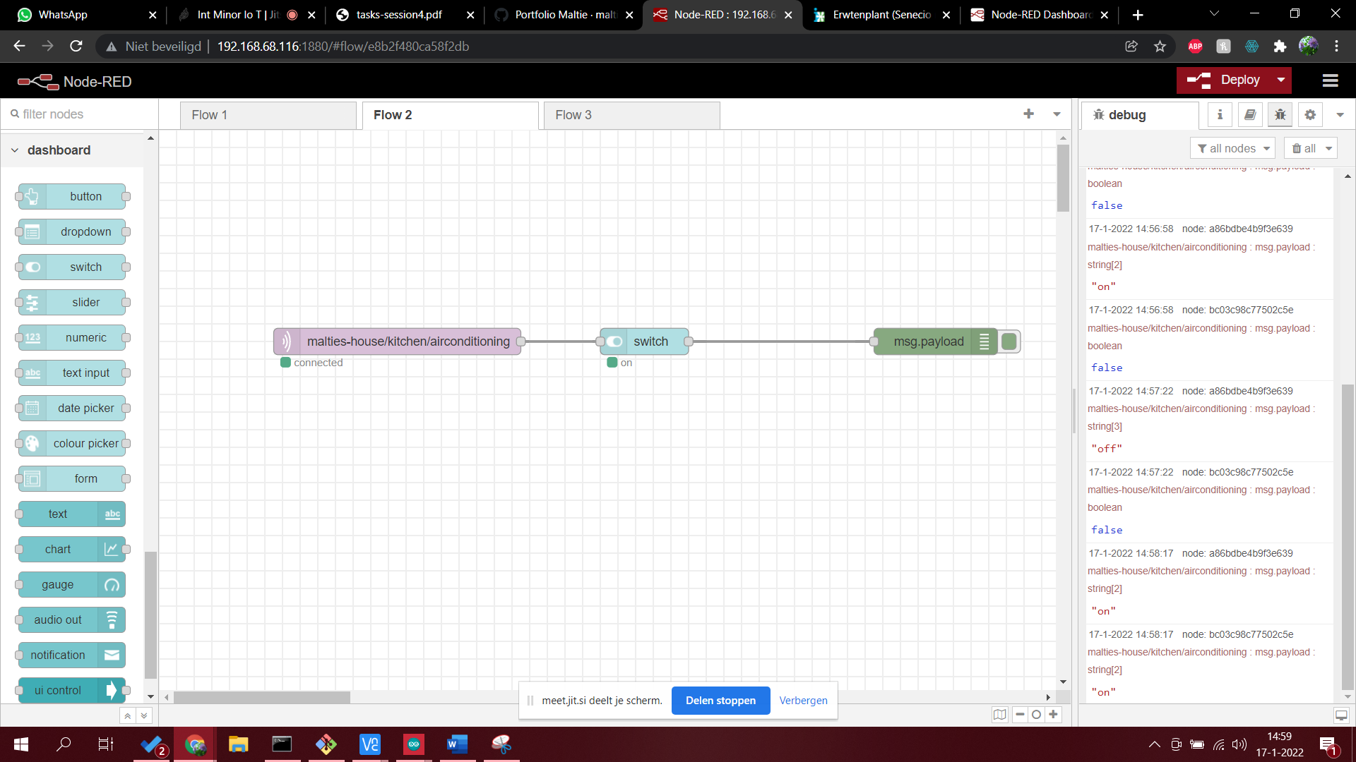

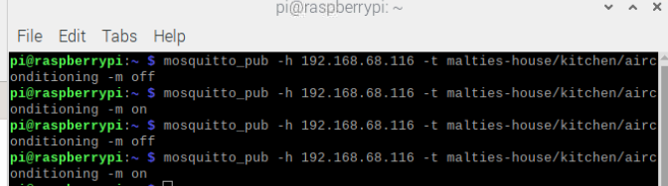

In the pictures above I make a switch in node-red which can turn something on and off. The message can be seen also in the mosquitto console.

3. Build an integrator component in Node-RED: switch at specific temperature (can be hardcoded) → needs to connect the upper two

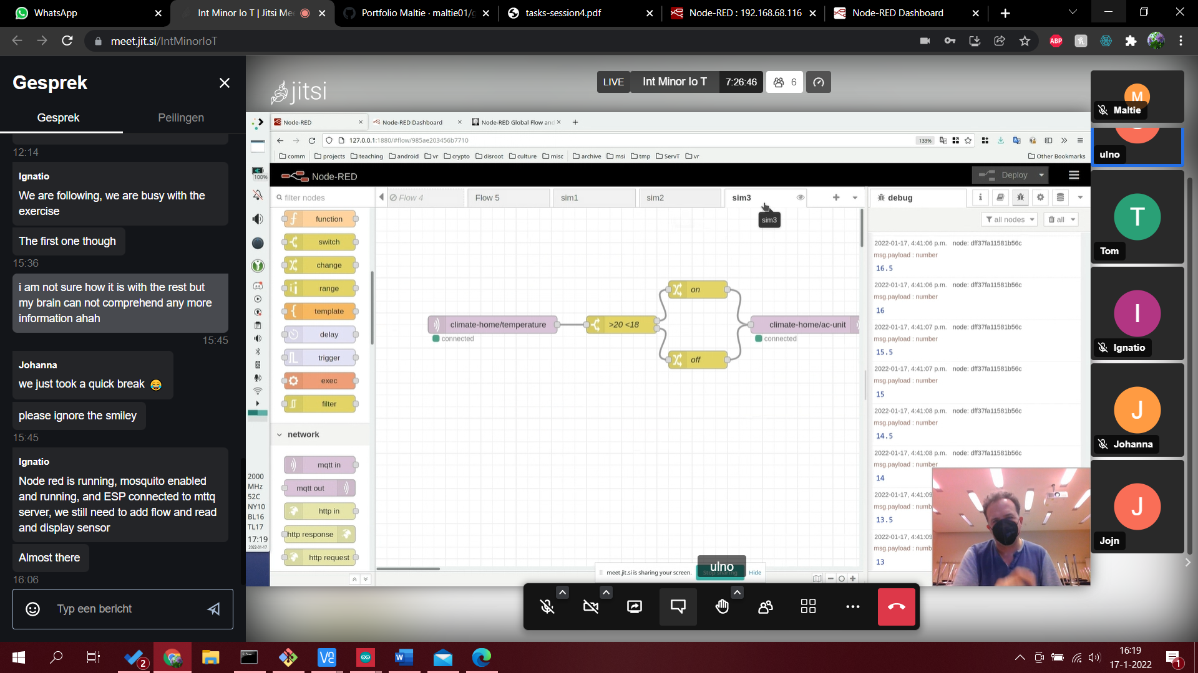

I did not make this exercise but it should look like this. It looks if the temperature is between 20 and 18 degrees and than it switches the air-conditioning on or off based on the outcome.

B. Hardware part

1. Implement AC unit in hardware
   * Build mqtt based switch (use relay) and switch for example 12v solenoid drawer lock, a pump, a fan, or just a led.
   * Get remote data via mqtt from the DHT22, DHT11, or Dallas onewire temperature/humidity device and show on dashboard as graph a[later task with display below as well as the remote OLED display (as value) (I used this library before, but you can try others and report your success: <https://github.com/beegee-tokyo/DHTesp>)]
   * Replace simulators with hardware and show it in action (chose good temperature switch point)

* Recommended Arduino MQTT client library: ["PubSubClient"](https://www.arduino.cc/reference/en/libraries/pubsubclient/)

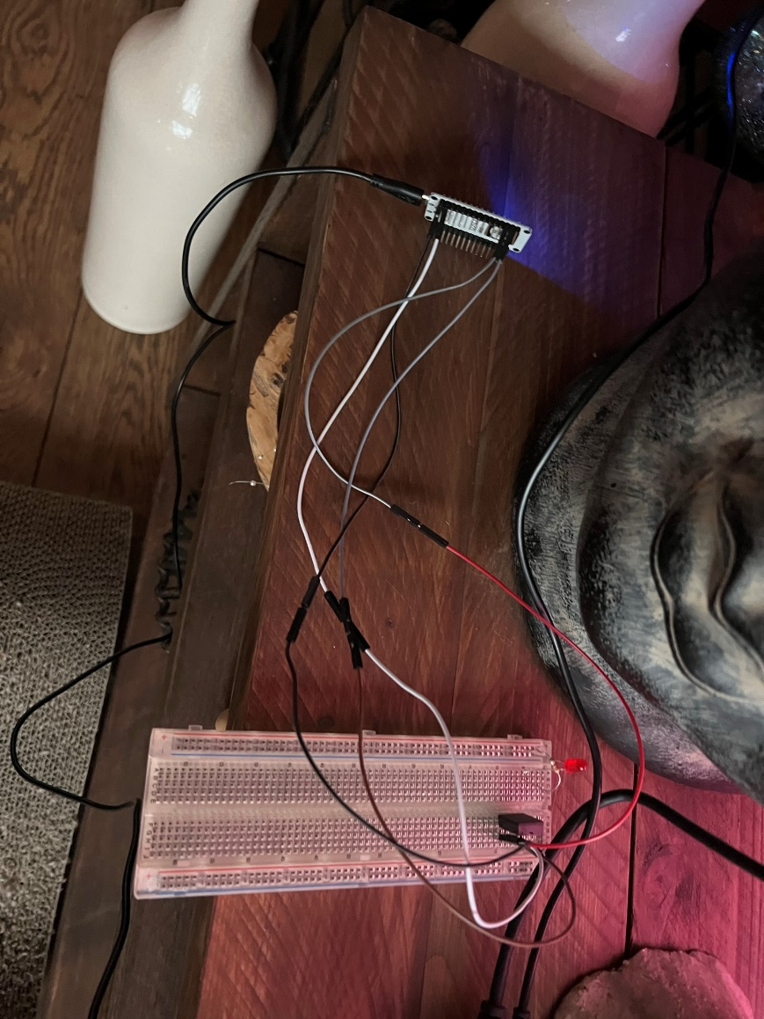

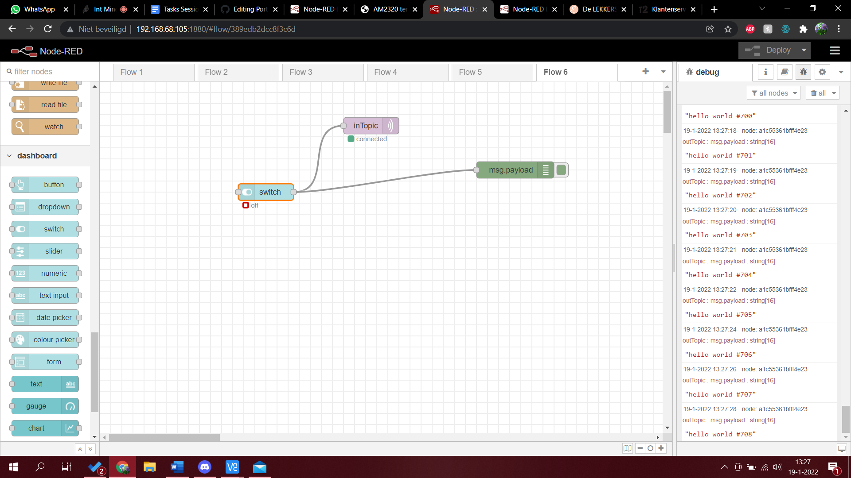

In this photo I show that I made a mqtt based switch that switched a led on and off.

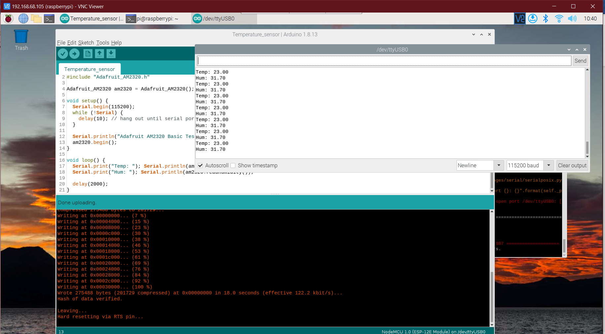

In this photo I show that I set up a temperature/humidity sensor and that it works.

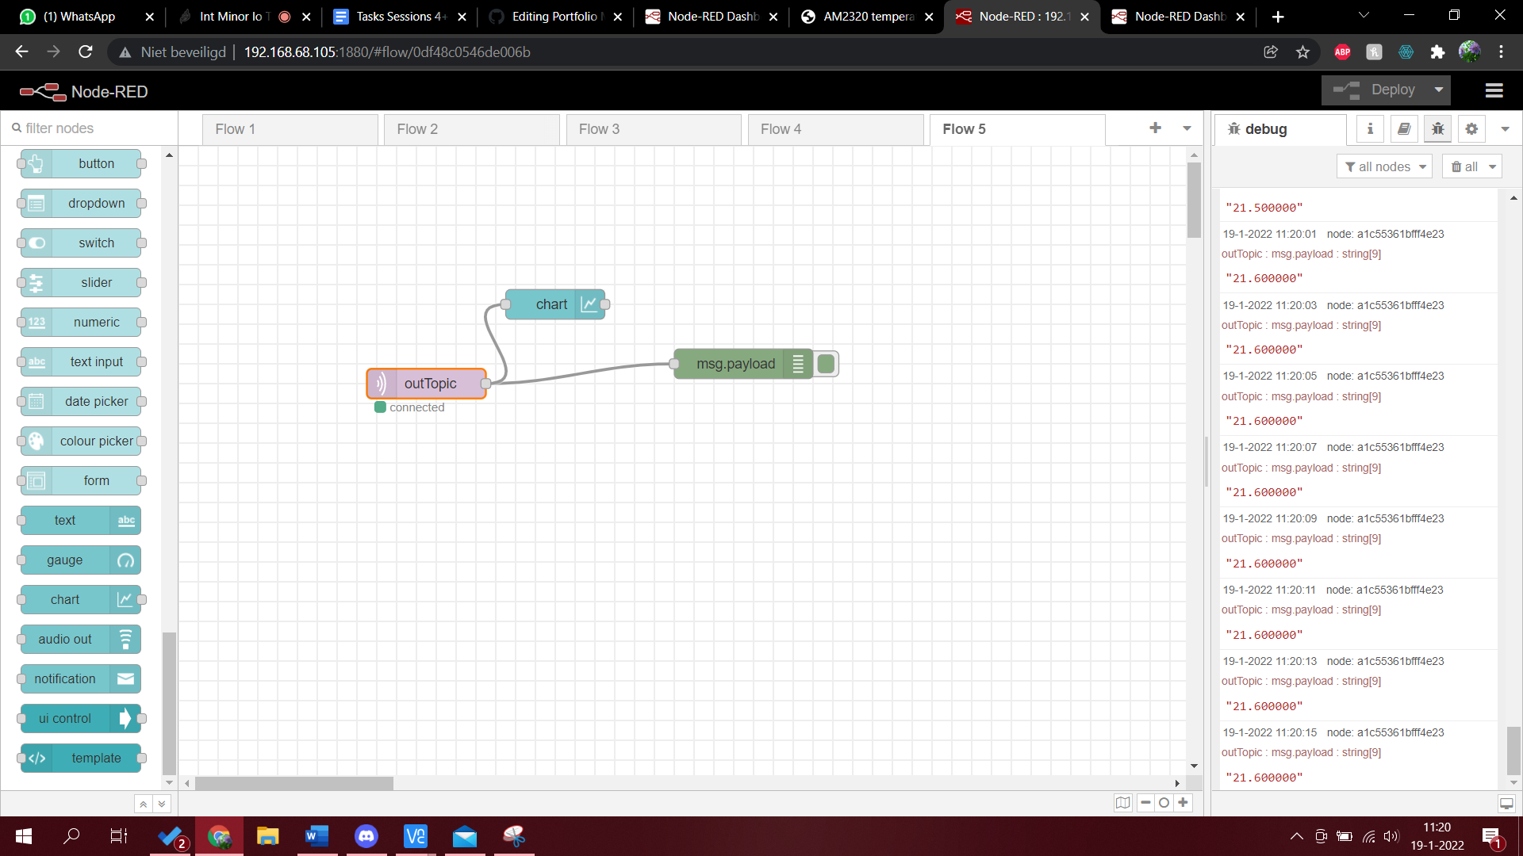

In this photo I show that I can connect the temperature sensor to node-red and that it shows the temperature in node-red which it can make a graph from.

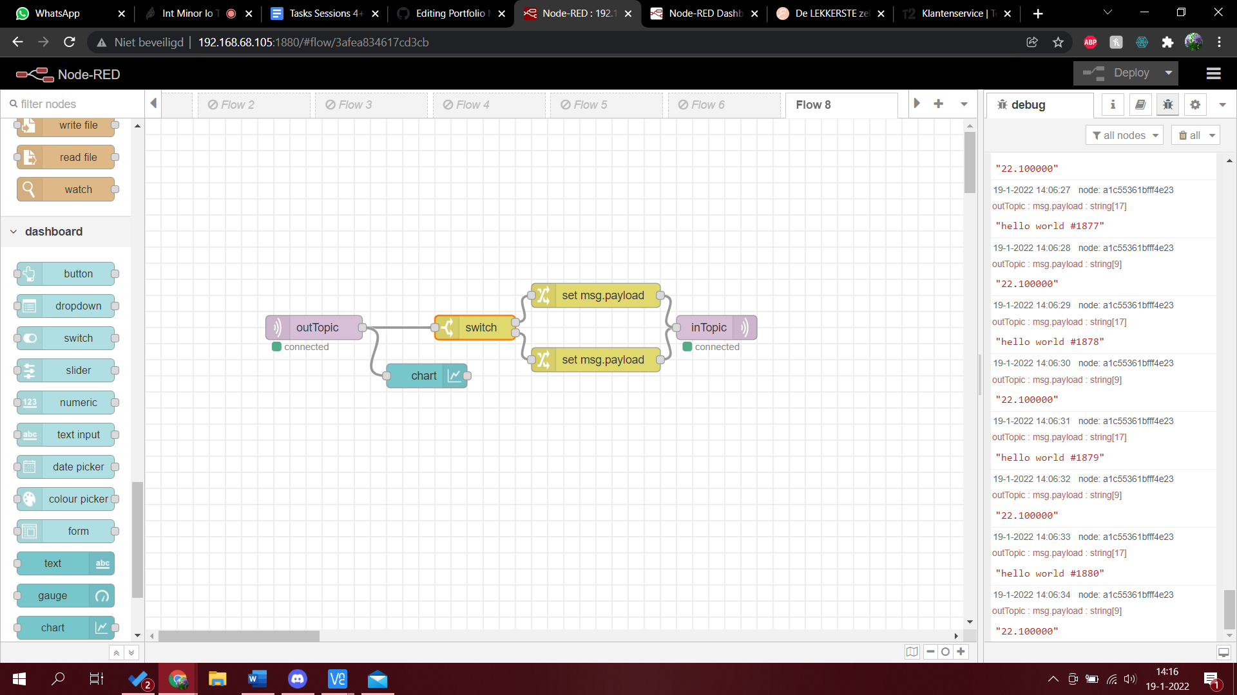

In this photo I combine the led with the temperature sensor. If the temperature is above 23.5 the led switches on. I divide these two with the out and in topic. Out is the temperature and in is the led.

# C. IoTempower

1. Study about [tool support in IoTempower](https://github.com/iotempire/iotempower/blob/master/doc/tool-support.rst) - Which commands are there, write down your first idea what they do and if or where you could use them (some of them give you extra information, when you call them with help)

run/iot: enter iot environment and run a iotempower command.

iot menu: giving a menu with all tools.

accesspoint: Turning wifi in an accesspoint.

iot upgrade: updating

iot install: install the iotempower environment.

**console_serial: Open a serial console to see debug output of a serially (locally) connected node.**

**initialize: Initialize a current node which is in reconfiguration mode or flashes a serially connected node and sets all initial configuration parameters like WiFi credentials and security keys (this is the same as the deploy serial command).**

adopt: connecting a device to the iotempower environment.

deploy: sends code to device

mqtt_broker: Start a local mqtt broker which can be used on all interfaces.

mqtt_listen: Giving the mqtt a certain topic where it should get data from.

mqtt_send: Send data with a certain topic.

**Iot doc serve: Run a documentation webserver on** [**http://localhost**](http://localhost)**:8001 (also compiles the documentation first).**

The commands in bold I could not think of any explanation so this is the explanation from the git.

1. Start the documentation server (iot doc serve). Attention, the search does not work as it is a local webserver without CGI support (extra credit for good suggestion/PR to make the python webserver do CGI). Open "Commands" and search how to use the rfid reader, PWM, a servo motor, ultrasonic distance sensor (RCWL-1601 or its 5V brother), and a single rgb led (you probably don't even need Google here, but if you are interested about more, feel free to find some more information about the hardware you are actually using) - note the example code you intend to use for both as well as some important remarks about wiring.
2. First Node: Follow the First Node manual and do all subtasks. For the step "Next deployments" connect the node to external USB power as suggested and show that the deploy step still works: <https://github.com/iotempire/iotempower/blob/master/doc/first-node.rst>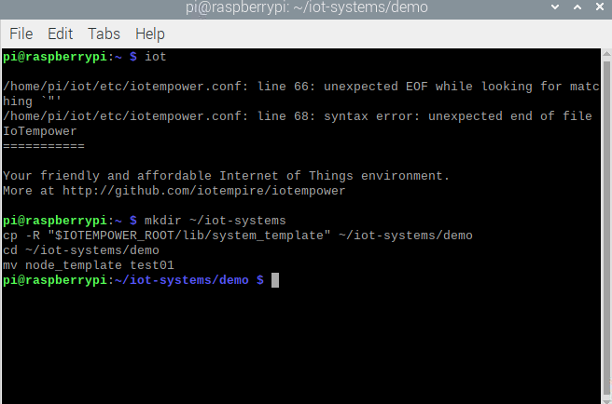

In this picture you can see a part of the first part of the tutorial. (Creating an IoTempower System Folder)

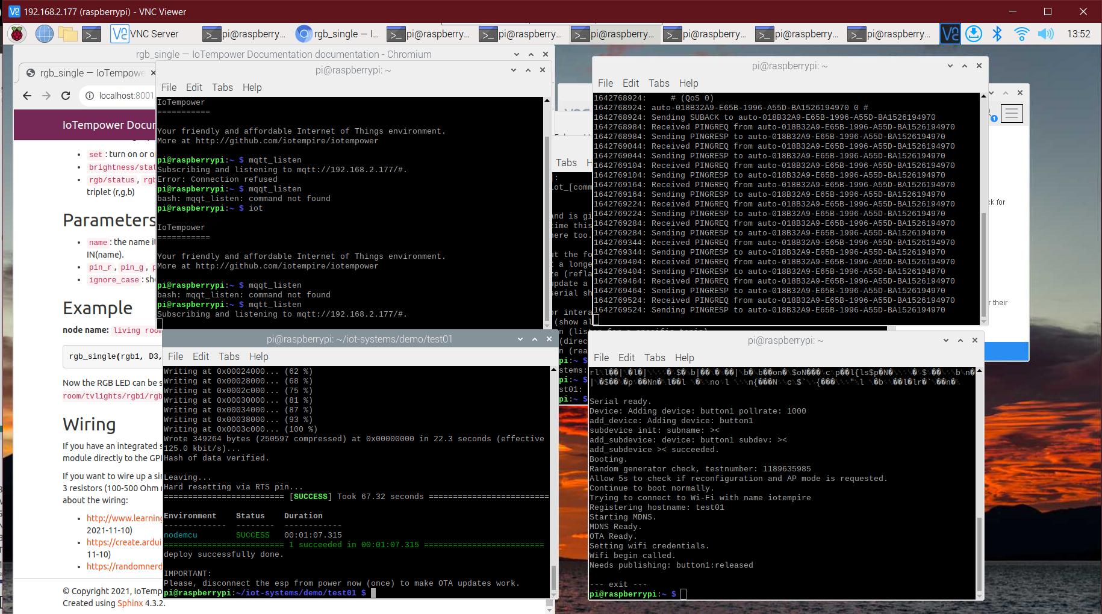

In this picture I show that I did the second part of the exercise: first deployment

The last part: next deployment I can not do now because I need a 2.4ghz wifi and I have 5.

On Friday night I finally had 2.4ghz wifi! I tried to do the work on Saturday but had limited time and because of that I made the mistake to not put my laptop on the same wifi. Tom pointed this out to me on Sunday. I unfortunately still have an error: 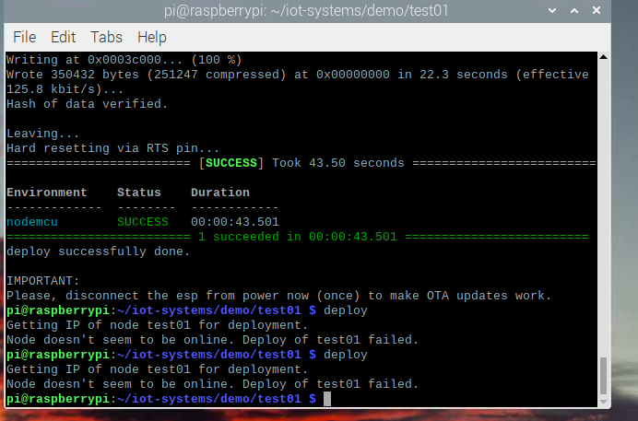

I can ping to the ESP and I redid the tutorial but I am not sure what is wrong. The next day I could not ping again and Ulrich helped me. It came to our attention that the wifi credentials were wrong on one letter. I felt very stupid but now it finally works.

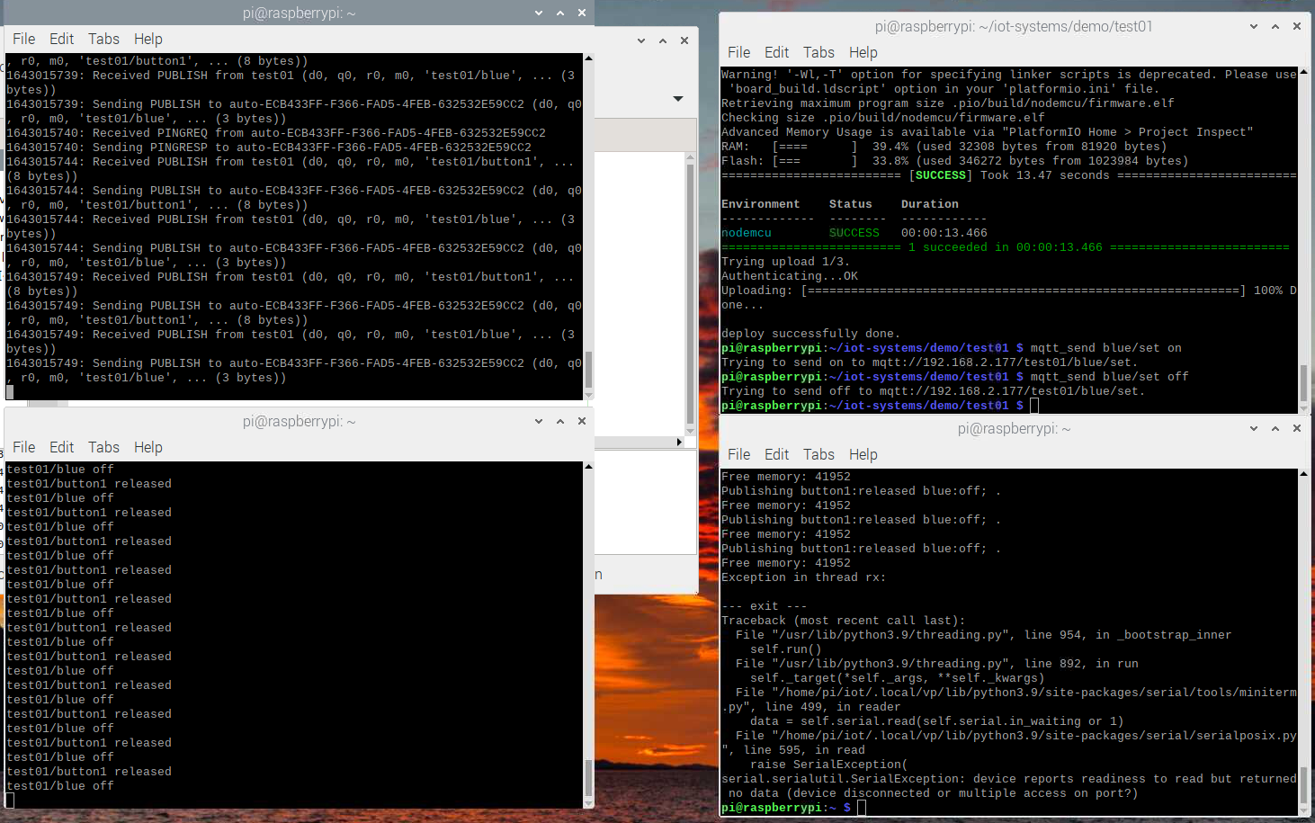

Above picture is proof of my working first node.

1. Second Node

Follow the manual here and do all subtasks:

<https://github.com/iotempire/iotempower/blob/master/doc/second-node.rst>

I am skipping this one to be on track again with the class and the exercises from class are also basically building a second node.

# D. More IoTempower and sensor/actors

Tom and I are working together. I do 2 and 8, Tom does 1-3-(5-6-7)

1. [This is a preparation task for the team that will build the access control system, if you do the liquid measuring challenge project, skip this task] RFID reader. Connect the RFID-RC522 RFID tag reader via SPI to a Wemos D1 Min or other esp, adjust its setup.cpp and re-deploy or flash. Evaluate the UID of the tag in Node-RED (check at least two rfid tags). Based on the detected UID, turn a new button on the dashboard either red and displaying "Access Denied" or green and displaying "Access Granted". If you press the button, reset its color and make it display "Scan Tag".

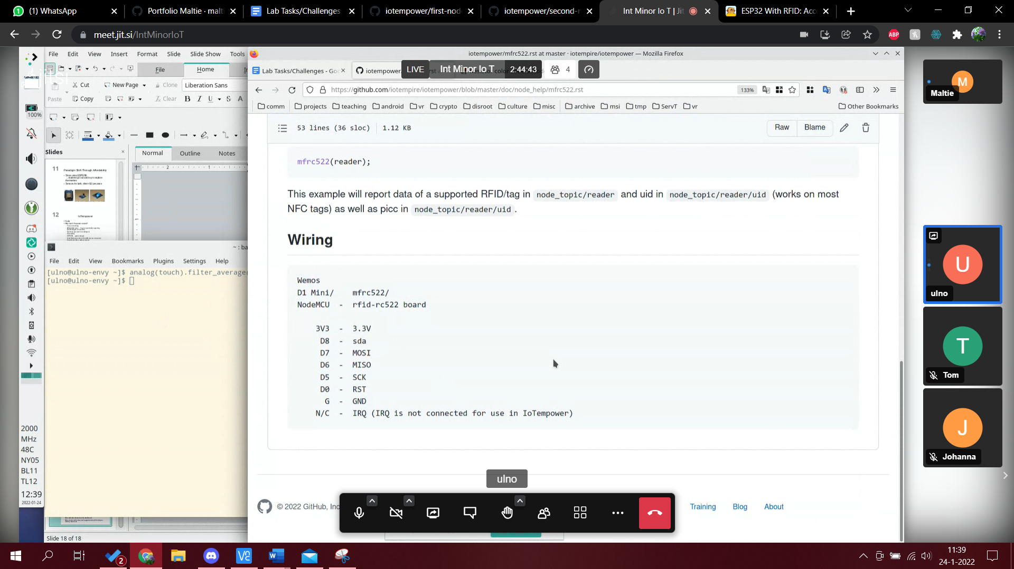

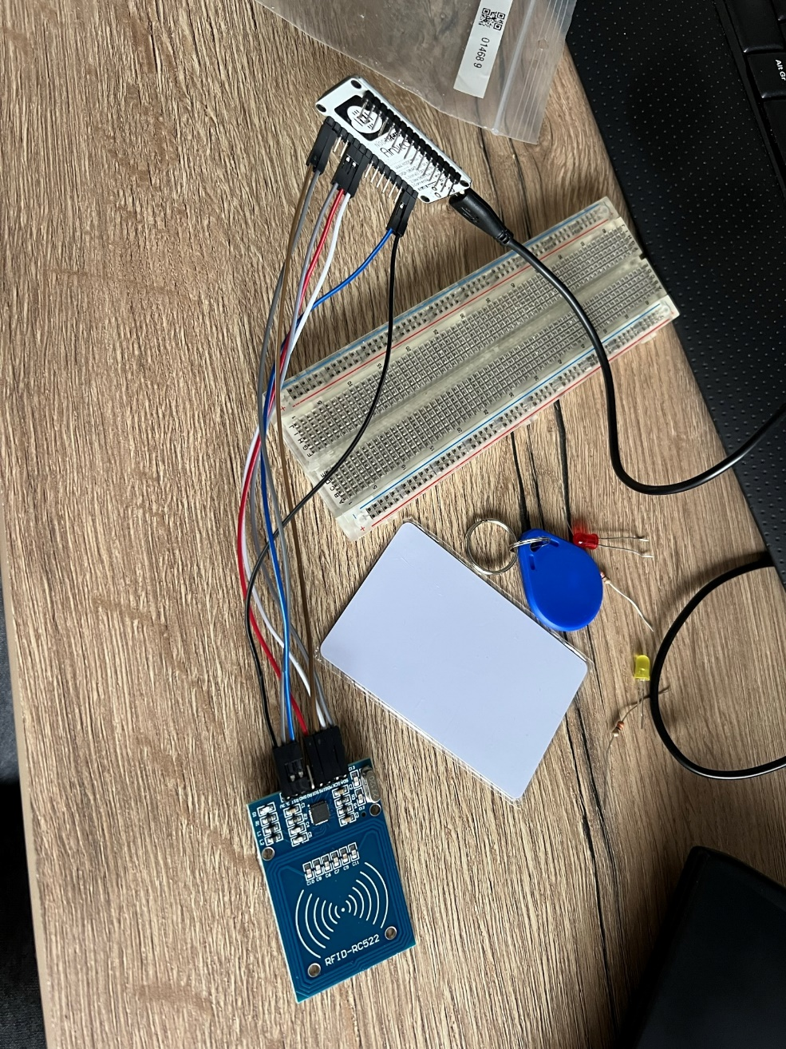

This is the wiring I have used.

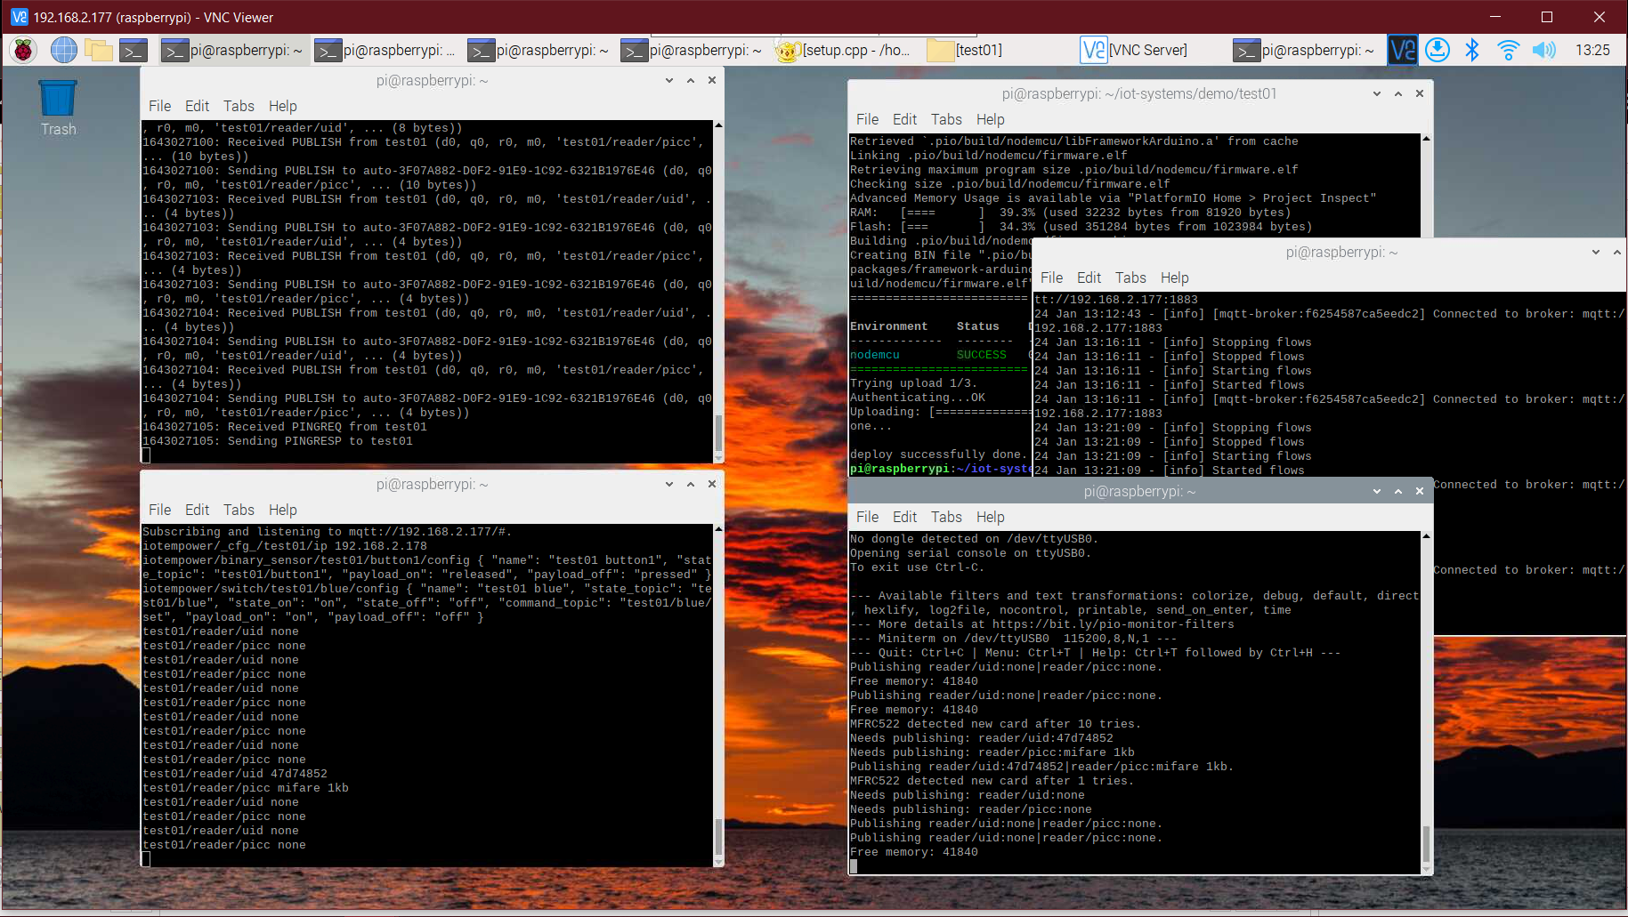

Above you can see that the basic rfid sensor works and that it works with mqtt.

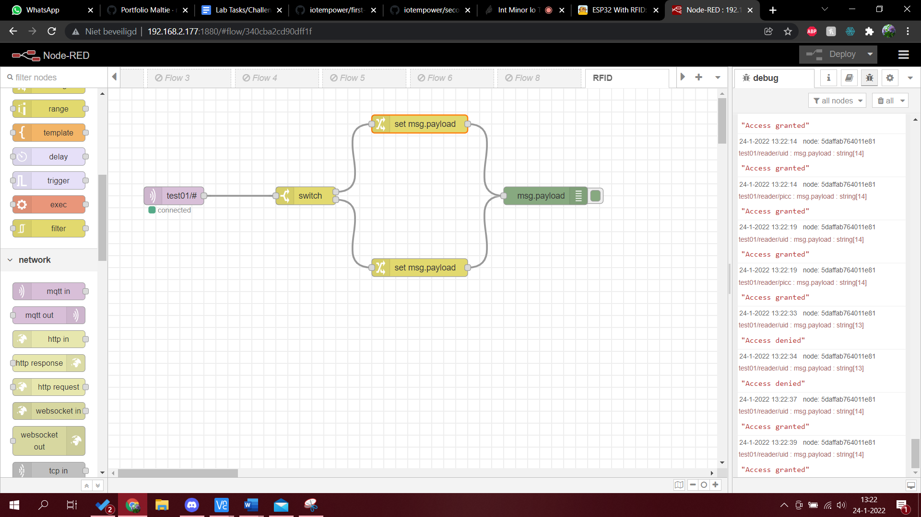

This is the first flow I made in node-red for the rfid. It works but now I need to expand the flow with UI.

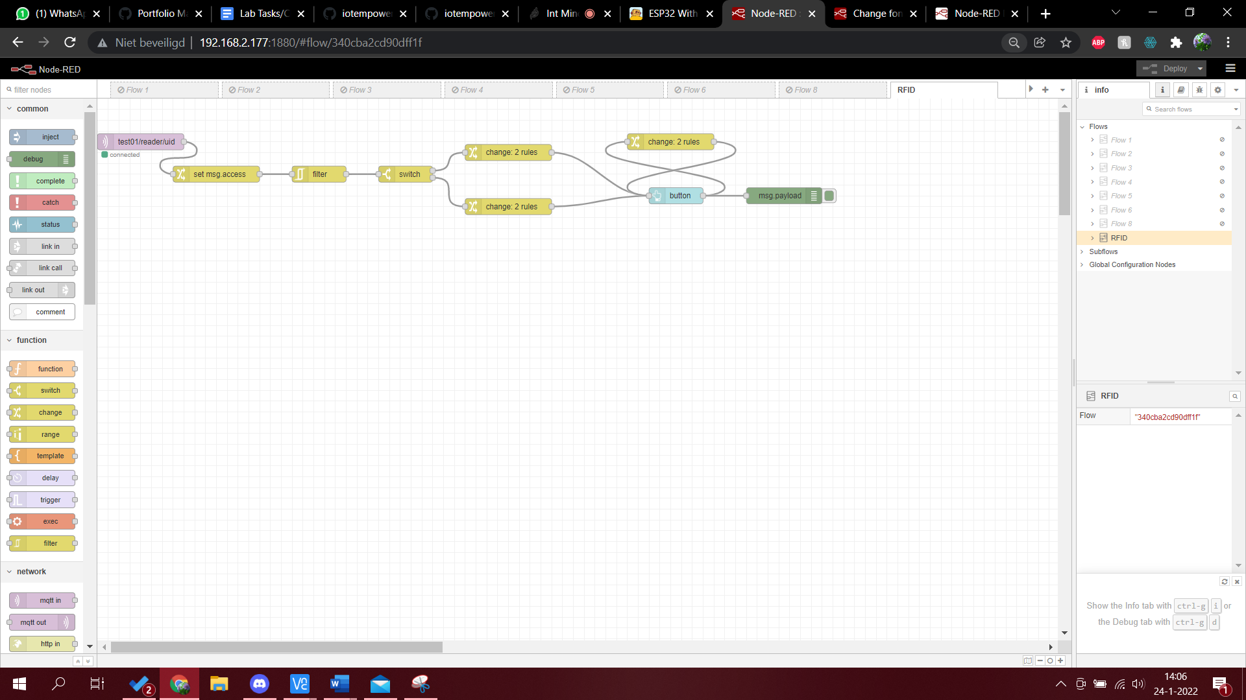

This is the expanded flow I made. Below you can see the UI that works with this.

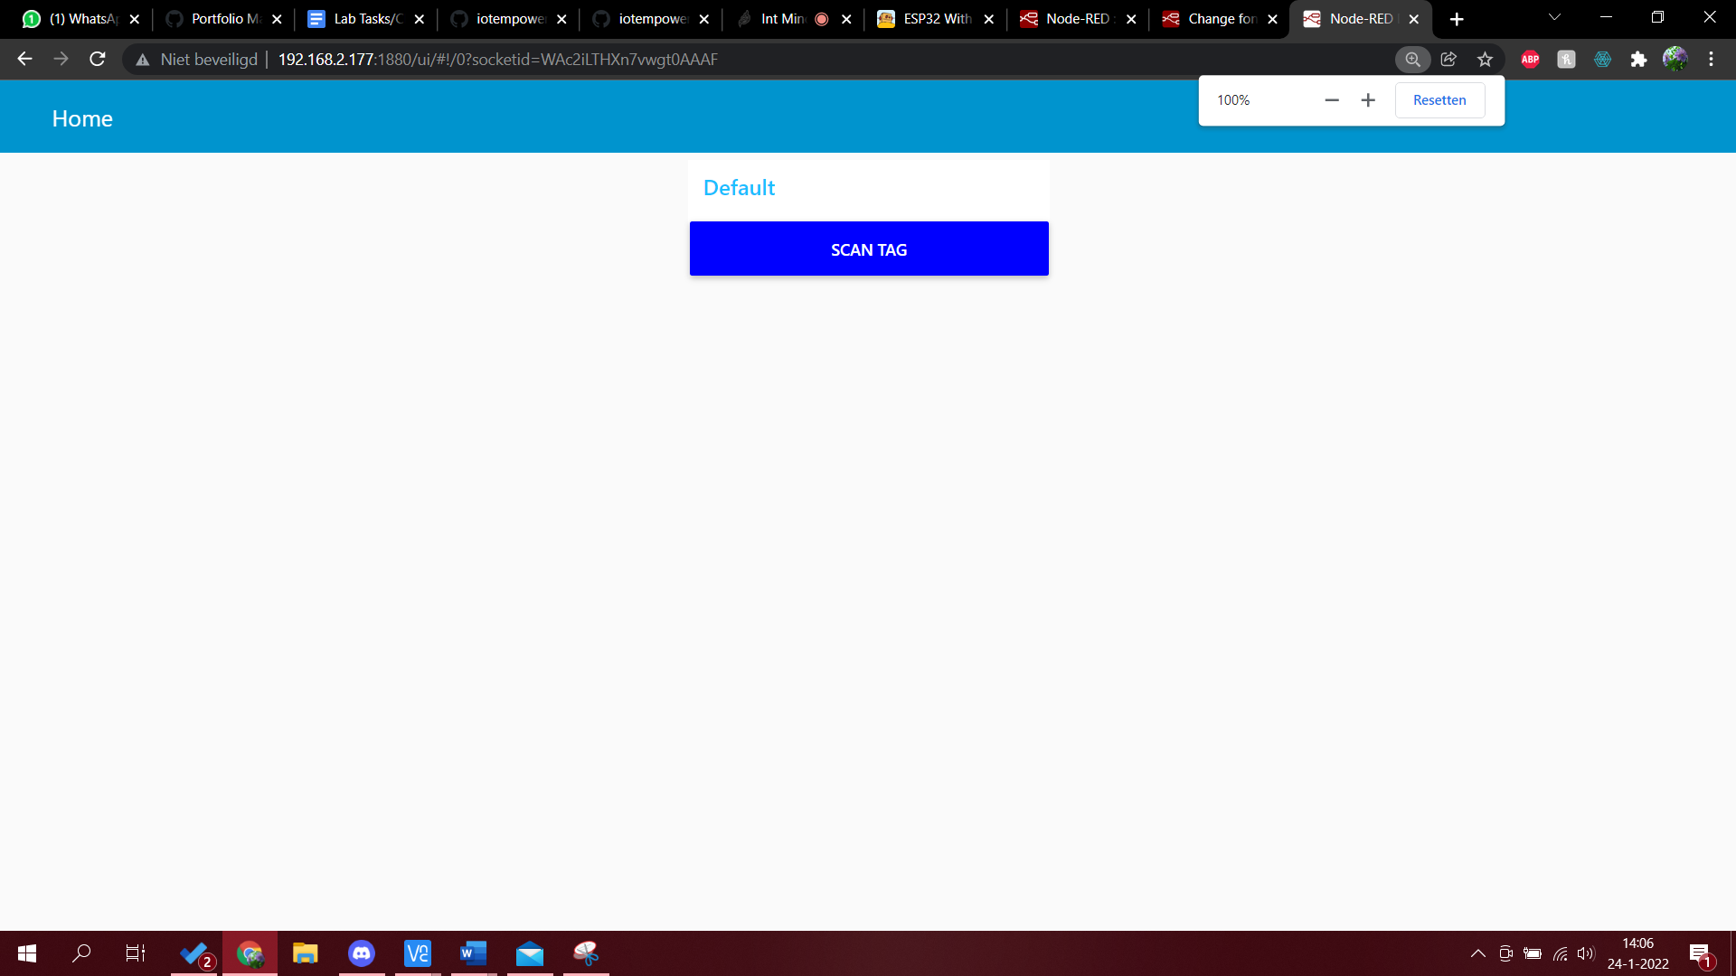

This is when no tag has been scanned and/or the button is pressed after scanning.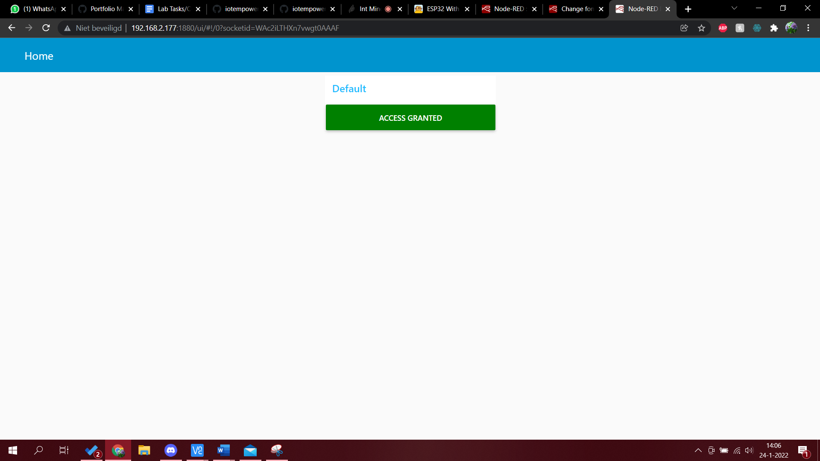

This is the UI when you scan the correct key.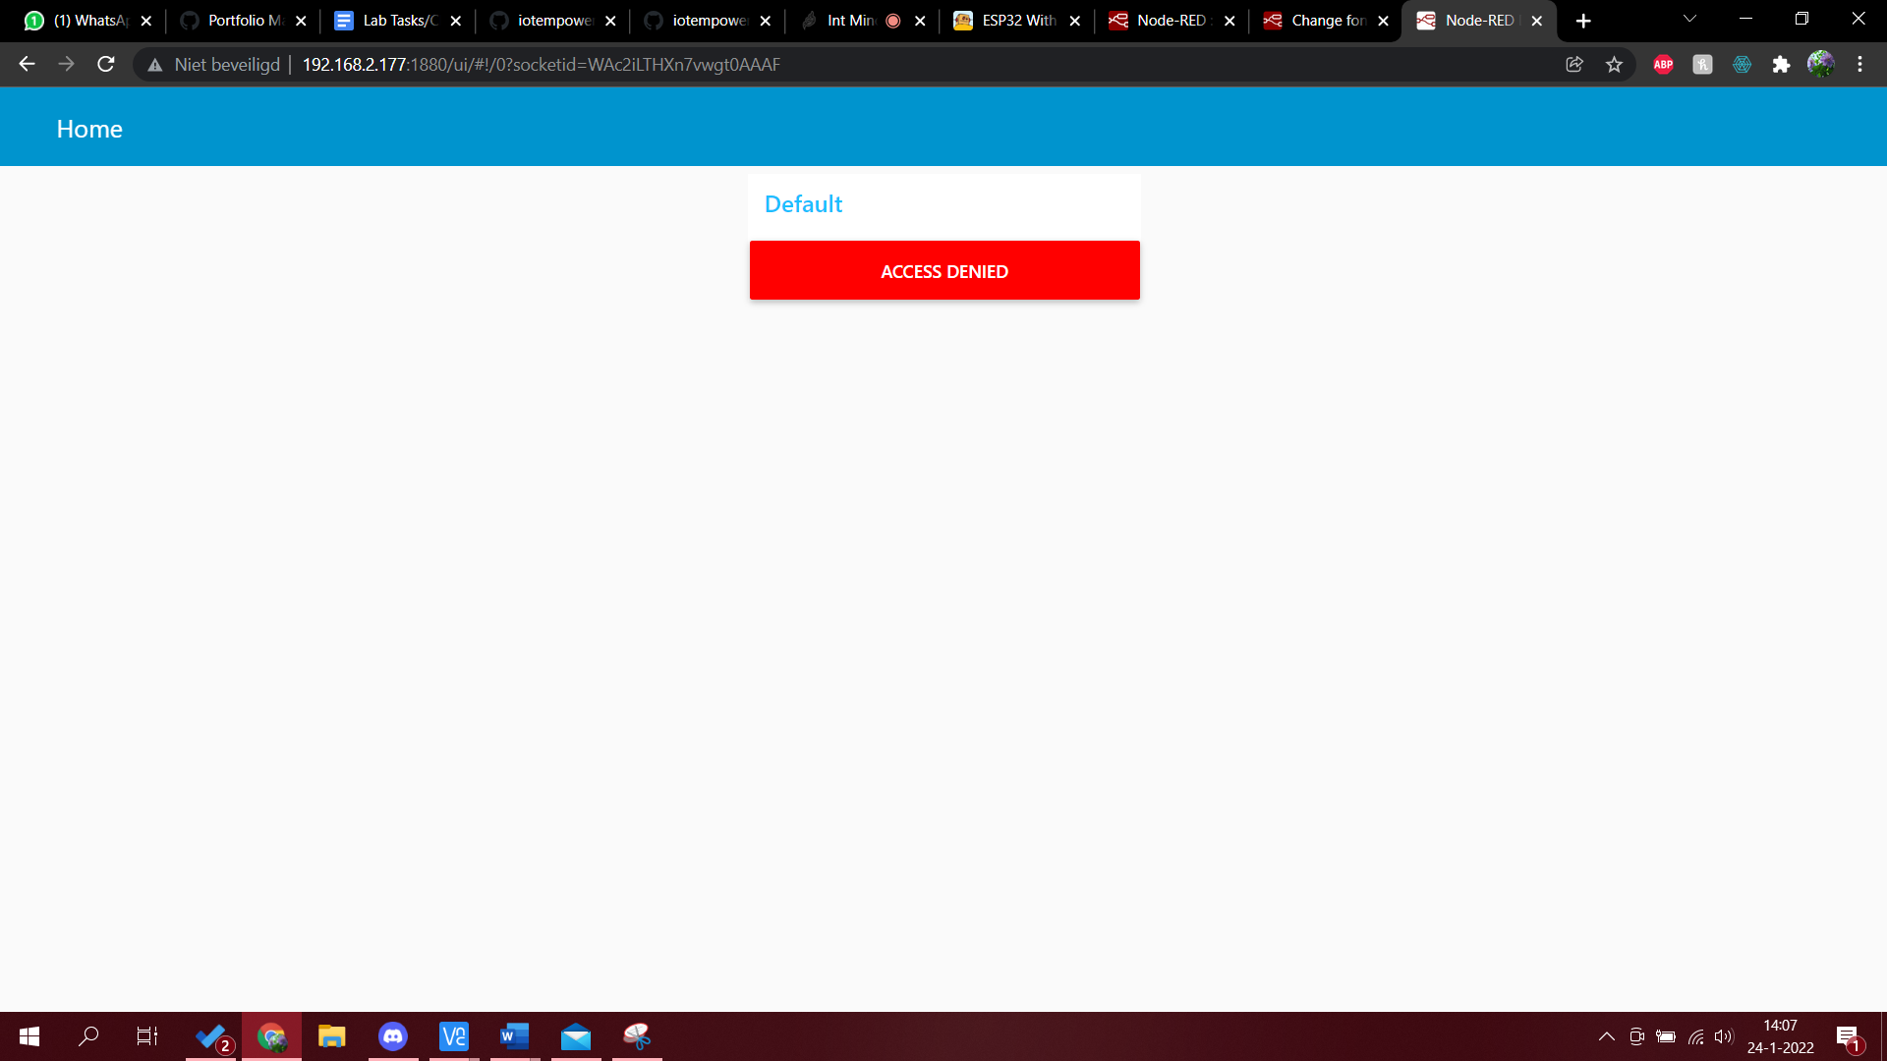

This is the UI when you scan the incorrect key.

1. Use the servo command to control your motors. Send an angle value with a slider from Node-RED. Some are true servo motors and should pick the angle that you send, the other ones are hacked servos where you select its speed with the angle value. The motors need 5V on their power input (please Google wiring of the SG90 servo first).

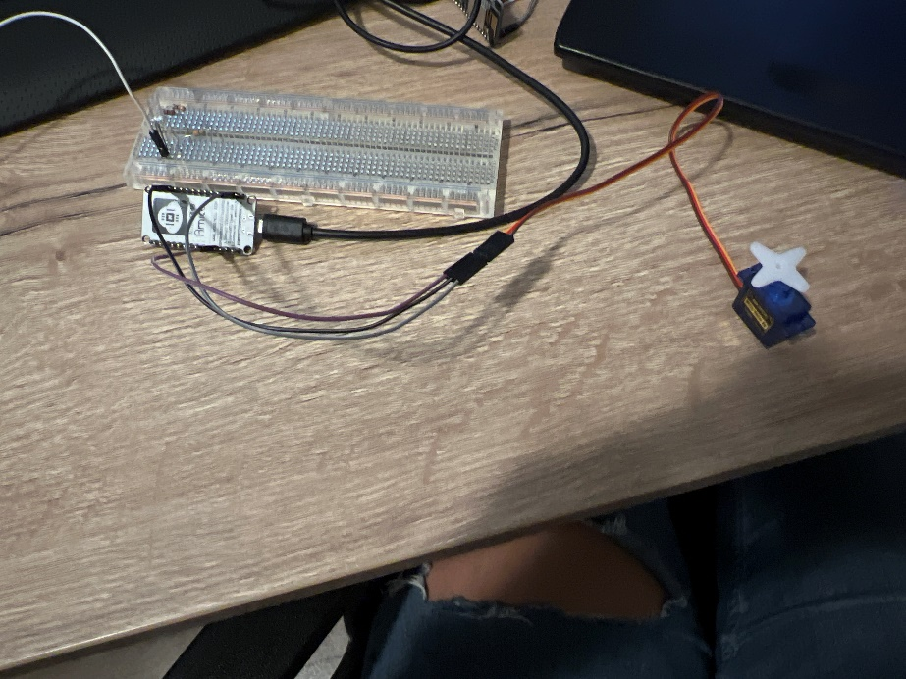

This is the wiring I have used. The motor is on 3v3 so it is a bit slow.

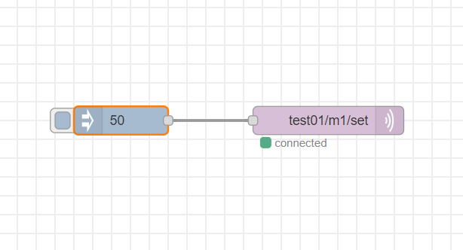

First I wanted to test a simple flow to see if I could make the motor work.

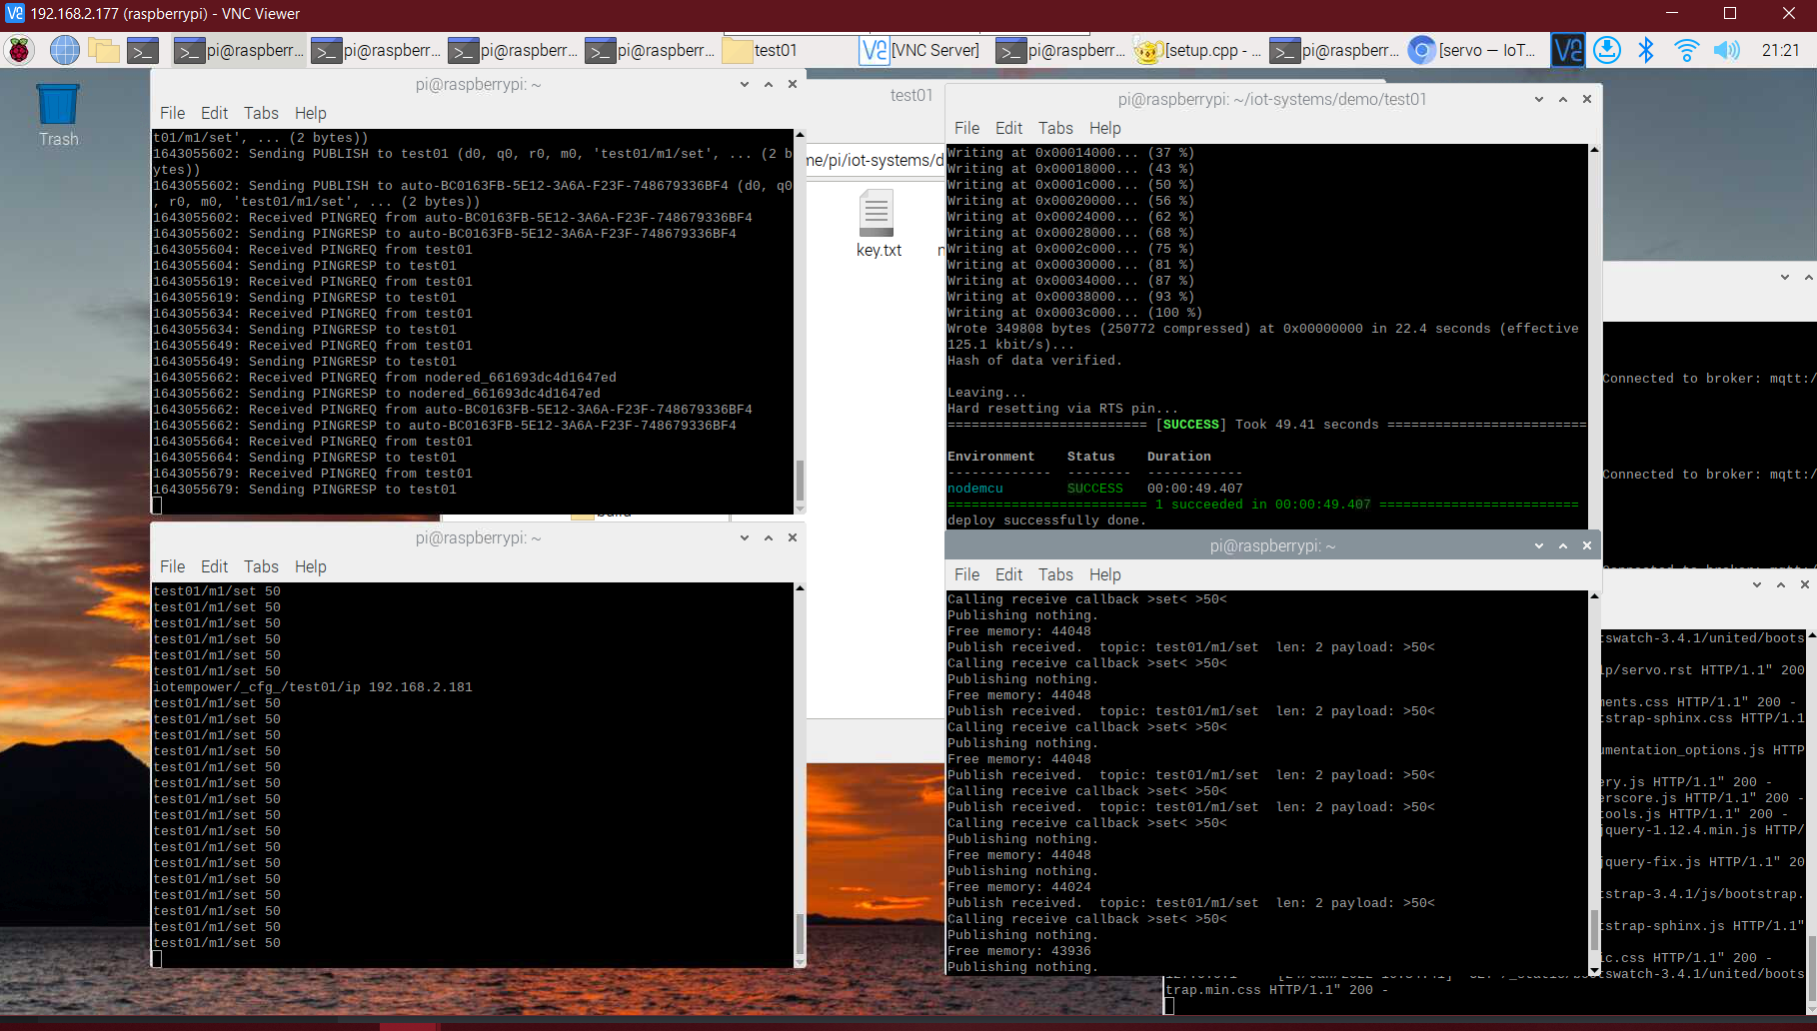

Here you can see that the flow sends the data to mqtt and the motor.

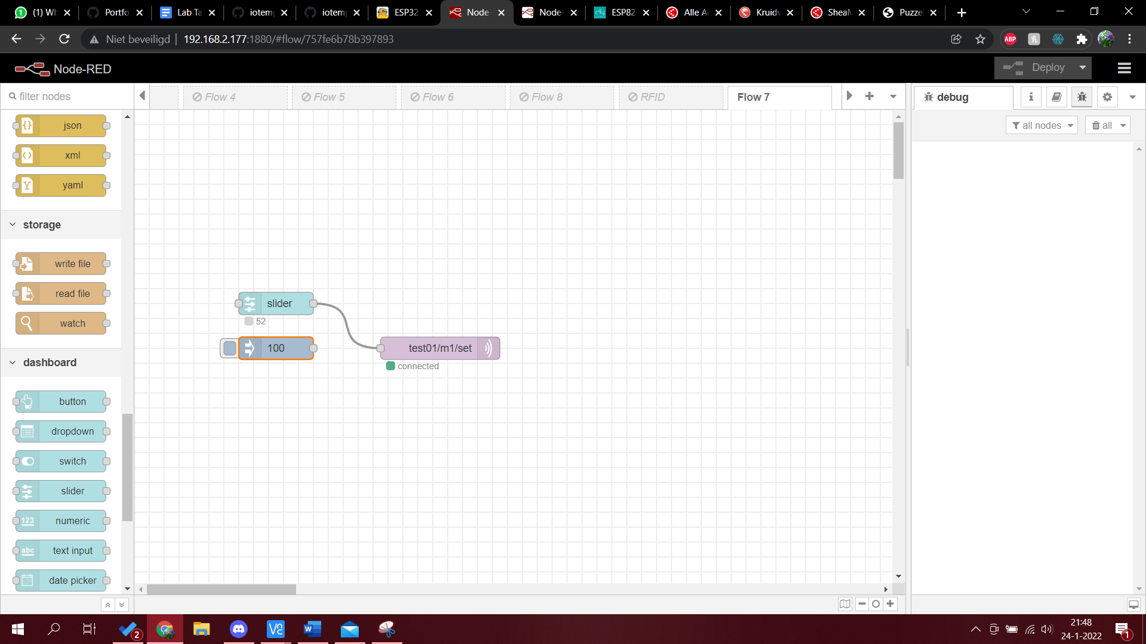

Now I want to make the motor work with the slider. If you slide between 0 and 100 and release the slider, this is the angle that the motor takes to turn on.

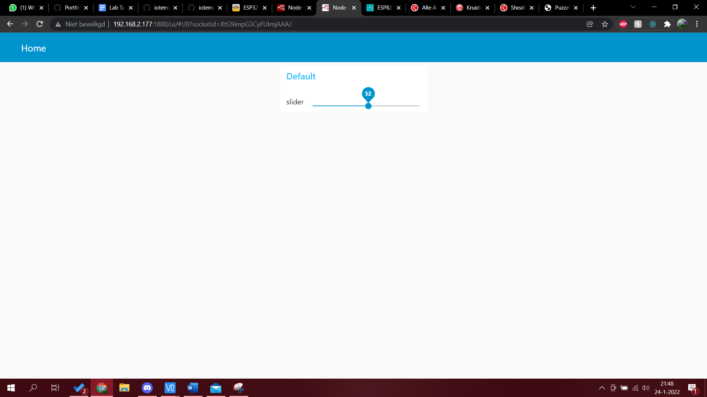

Here you can see the slider.

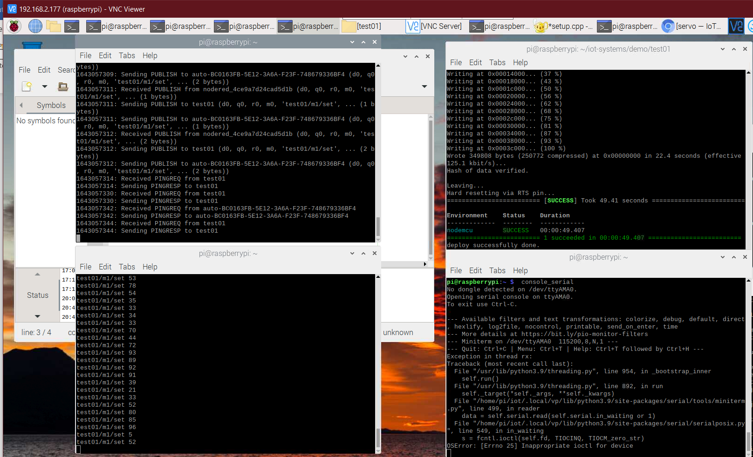

And here you can see all the different variables the slider sent over mqtt to the motor.

# E. Project

For the project we expand the rfid exercise from above. I have made the rfid exercise so that part is on me. I succeeded in wiring the rgb led to a second nodemcu but after this is got a bit to hard for me and because class was ending and Tom already succeeded in the second half I decided to work on exercise 8 from above.

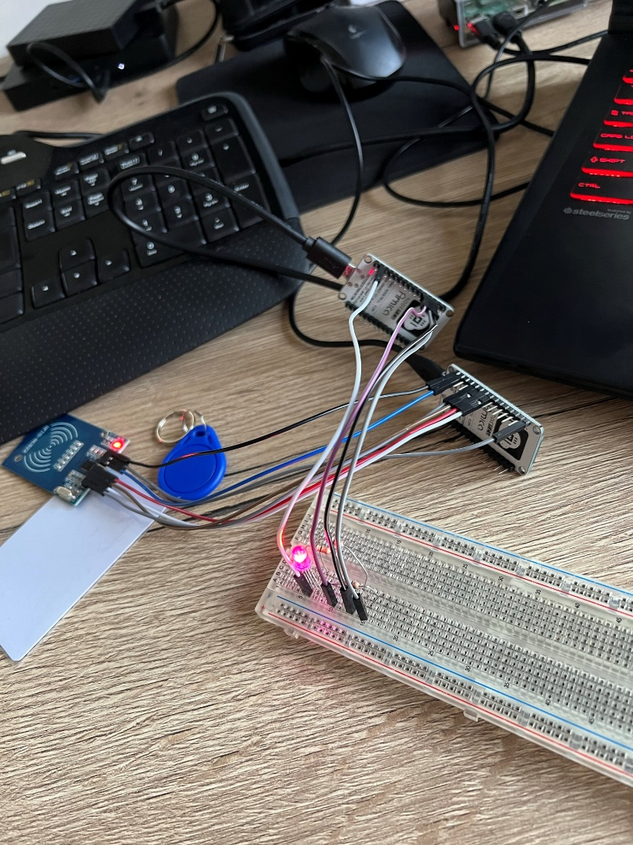

## Led strip

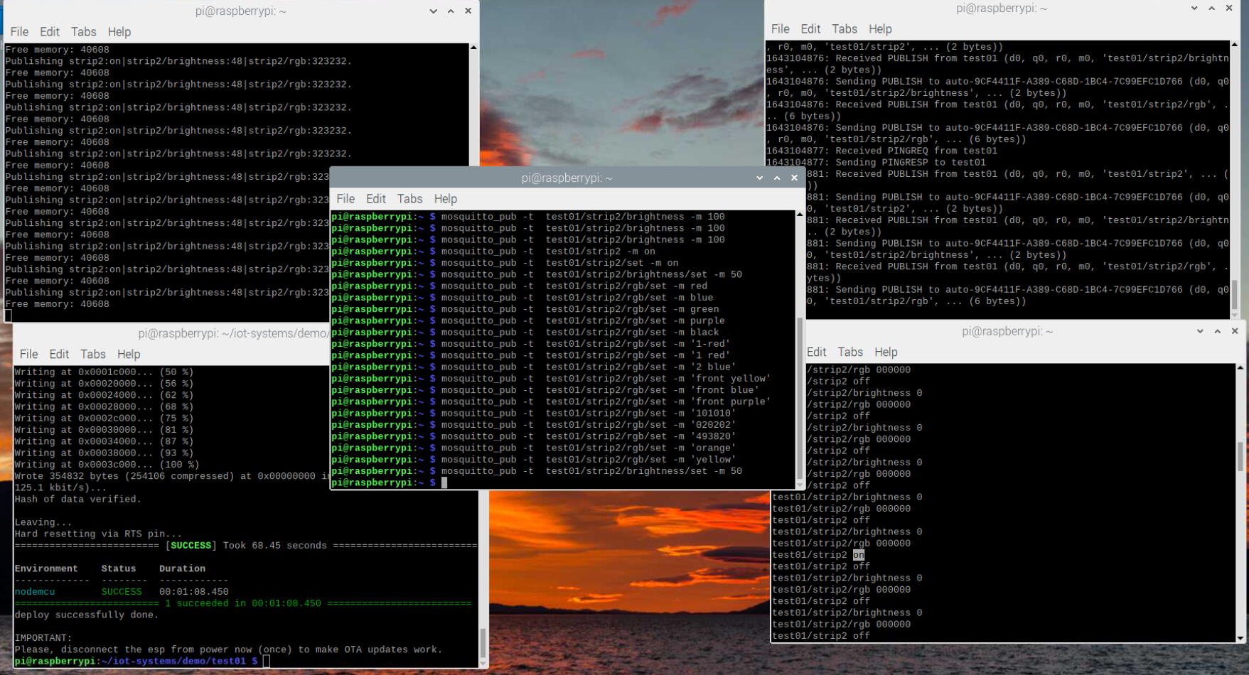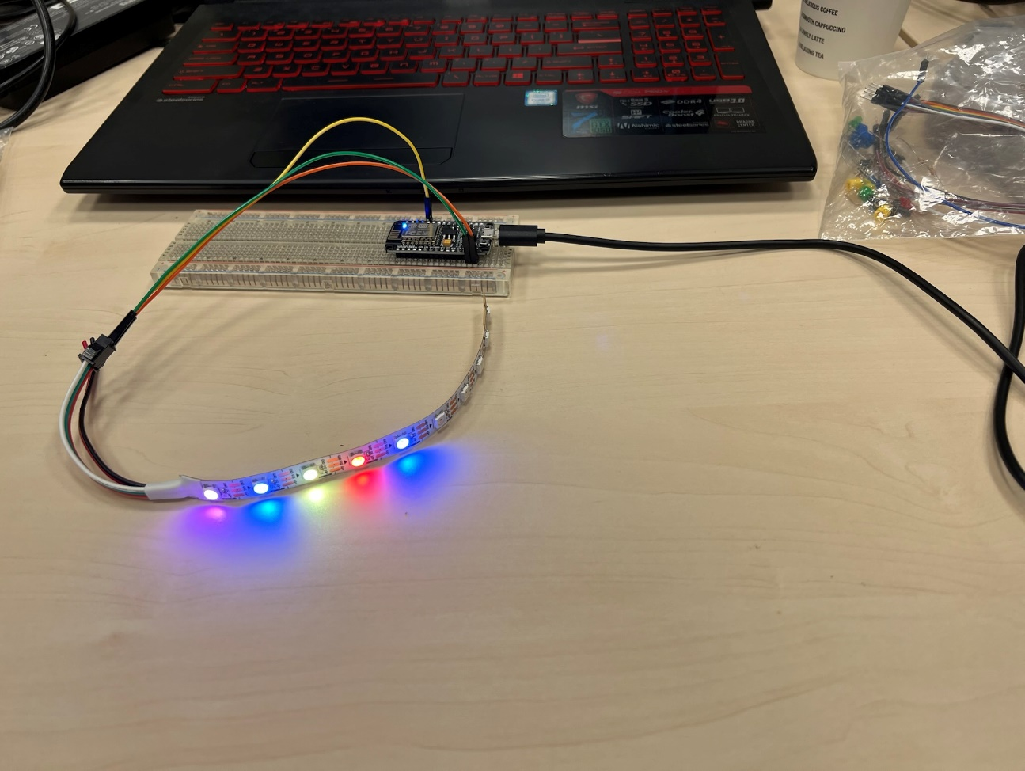

I cut the led strip to 10 leds and connected it to the ESP. With these pictures I show that I am able to get the led strip working and that I understand how I can change the lights.

## Ph sensor

At school Tom and I worked together on the PH sensor for the project. I did the LED exercise in the morning and in the afternoon I made the scenario and Tom worked on the sensor. When he got the basics of the sensor we then worked together to get it work on my pi. I ran the commands and we made the node-red flow together. Tom made a video about the PH sensor working. The LEDs turn a different color when the PH is below or above a certain level. For the rest of the PH sensor I refer you to Tom’s portfolio.

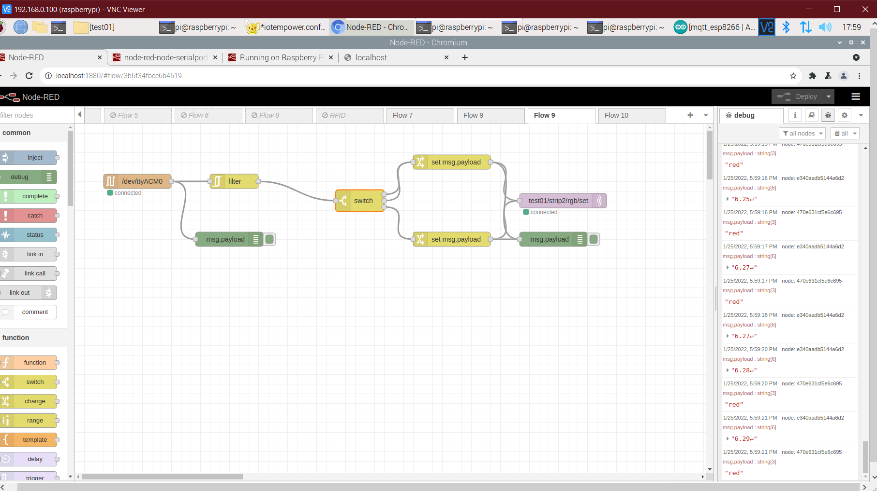

### The scenario

Main character: Pablo Holland

App: check my water

Pablo is a South African student at the Fontys Hogescholen. He is 20 years old and lived in Venlo.

During the second semester of the school year Pablo has the opportunity to go back to South Africa for the whole semester. Pablo is flying at 06:00AM to Johannesburg. In South Africa it is not really clear when the water is drinkable or not. He takes some water bottles with him because he does not know where he can get safe water when he lands in Johannesburg. Pablo forgets the fact that he can not take any fluids with him. At 05:00AM he wants to go through customs. He then thinks again about the rules and before he goes into customs, he throws away his bottles of water. At 06:00AM the plane takes off. Around 08:00PM the plane lands in Johannesburg. At 09:00PM Pablo receives his suitcase and is very thirsty. But, he does not want to buy a new bottle. He wants to save the turtles. The actual problem is that he does not know if the water is safe to drink at the airport, so he does not drink it. He takes a cab and at 10:00PM he arrives at his home. Unfortunately Pablo did not look correctly and his house is on the other side of the city. He is extremely thirsty but he does not see a store or something else near him. He walks and walks and around 11:00PM he sees a sign. This signs says: ‘You thirsty? Download CheckMyWater!’

The CheckMyWater app uses multiple sensors, like a PH sensor, to measure the quality of the water in several places. Then it gets send to the app with an API and then the user can see the quality of the water in their area.

Pablo is indeed very thirsty and can not stand very long on his legs anymore. He downloads the app and sees that there is a water spot near him. The PH level is good and the app says it is safe to drink. Pablo fills his water bottle 3 times because he was so thirsty. He quickly feels better again and can walk the last 30 mins to his house. At 11:45PM he arrives at his house and is very relieved. He quickly sees on the app that the water here is also safe to drink for now so he is happy about that. The CheckMyWater app saved the day for Pablo and he can now rest and begin his semester hydrated.